Smartypants Exclusive Childcare Holiday Club
194 Hibson Rd, Nelson, Lancs BB9 0DZ Tel: 01282 931310
Email: Colette.smarty@hotmail.co.uk

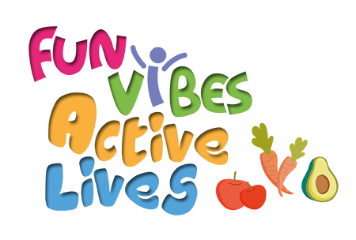
Booking Request Form

Name of Child ____________________________ DOB__________________

School ____________________________ Year__________________

Special Access Requirements: Y/N

Has your child previously attended Smartypants nursery or our Holiday club: Y/N

Do you have a Fun Vibes, Active Lives Voucher? Y/N
If Yes please insert your activity code here: ____________________

Does your child access benefits-related Free School Meals? Y/N

Special Dietary Requirements: ______________________________________________

Medical Conditions/Allergies: _______________________________________________

Days and times required:
Monday | Tuesday | Wednesday | Thursday

Parent Full Name: __________________________ Contact Number:_____________________

Thank you for your application, we shall review your request and contact you with details

By registering interest in our Holiday Club and the Fun Vibes, Active Lives programme, you are consenting to share contact details with Pendle Council and Pendle Leisure Trust. All data will be held confidentially and will only be used to ensure you meet the criteria for free provision and for monitoring and evaluation purposes

RS/Reg docs website holiday booking form FVAL

